**Name: Session:**

**Programming II**

**Lab Exercise 2.21.2024**

1. Create an application that allows the user to enter two integers. The application should determine that the values are equal or which is larger than the other. Before comparing the numbers, use the TryParse method to verify that both inputs are valid integers. If an error is found, display an appropriate error message to the user. Provide a Clear and Exit button to the application.

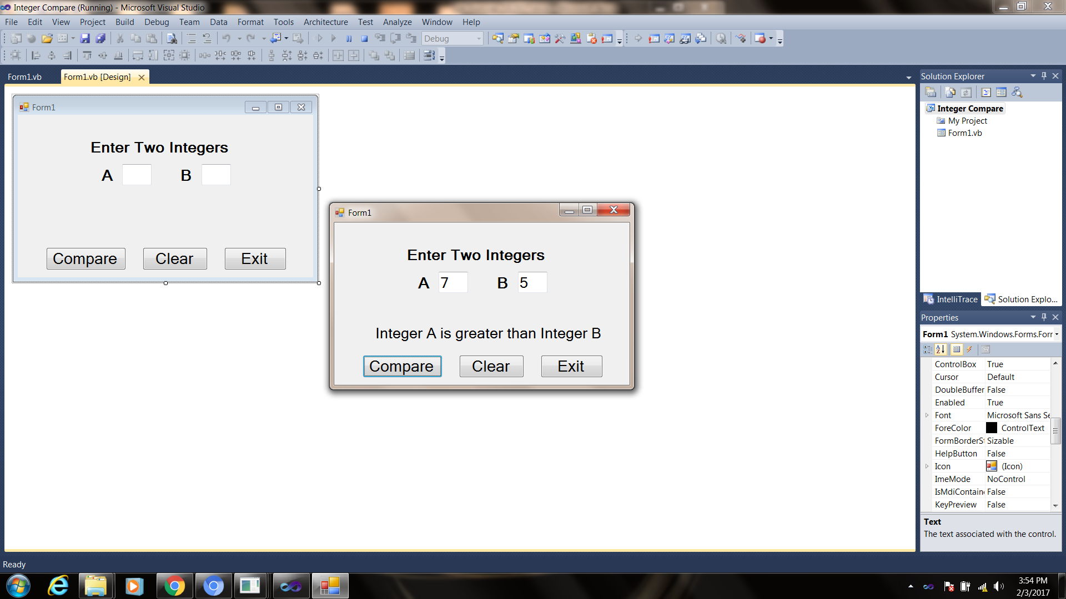

1. Create an application that allows the user to enter the names of three runners and the time it took each of them to finish the race (hours:minutes:seconds). The application should display who came in first, second, and third. You can assume that no two runners have the same finishing times. Add a Clear and Exit button to your application.

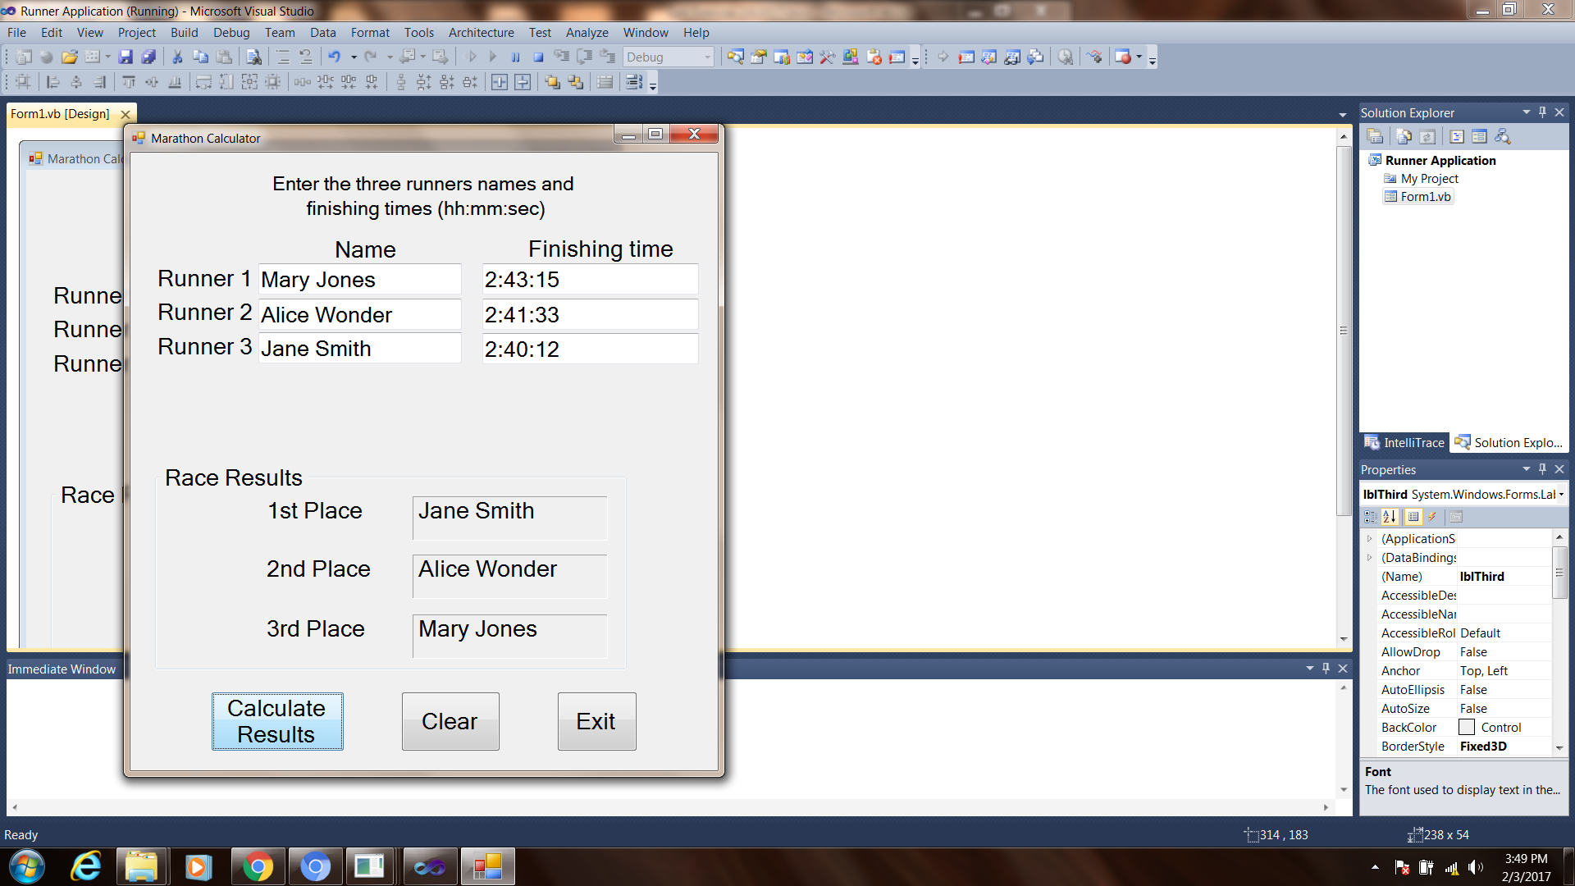

**Using TryParse**

Convert a string representation of number to an integer, using the int.TryParse method in C#. If the string cannot be converted, then the int.TryParse method returns false i.e. a Boolean value.

Let’s say you have a string representation of a number.

string myStr = "12";

Now to convert it to an integer, use the int.TryParse(). It will get converted and will return True.

int.TryParse(myStr, out a);

**Example**

using System.IO;

using System;

class Program {

static void Main() {

bool result;

int a;

string myStr = "12";

result = int.TryParse(myStr, out a);

if (result)

Console.WriteLine("String is an integer representation: " + result);

else

Console.WriteLine(“String is not in integer representation”);

}

}

**Output**

String is a numeric representation: True

**When you have completed problem 1 and 2, submit their source code as a screen shot of your applications. Attach these to this sheet and turn in.**